Waters of Life: Survey of a Riparian Area
Yellowstone National Park
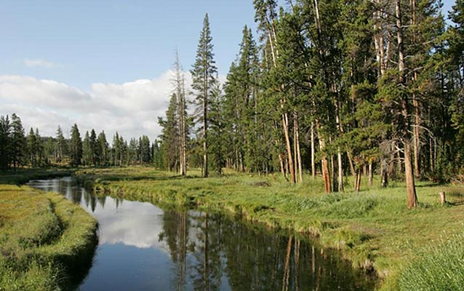
Obsidian Creek, Yellowstone National Park. NPS/Peaco

SUBJECT:
Art, Biology: Animals, Biology: Plants, Botany, Earth Science, Ecology, Environment, Landscapes, Wildlife Biology
DURATION:
1-2 hours
GROUP SIZE:
Up to 24 (4-8 breakout groups)
SETTING:
outdoors
NATIONAL/STATE STANDARDS:
CCSS.Math.Practice.MP5
CCSS.ELA-Literacy.CCRA.W.10
CCSS.ELA-Literacy.CCRA.SL.1
CCSS.ELA-Literacy.CCRA.SL.4
CCSS.ELA-Literacy.RST.6-8.3
CCSS.ELA-Literacy.RST.6-8.7
Next Generation Science Standards: MS-LS2-1., 3-LS4-3.
KEYWORDS:
abiotic, aquatic, art, biology animals, biology plants, biotic, botany, earth science, ecology, environment, landscapes, riparian, scat, wildlife biology

Overview
Students investigate plant and animal life in and around a creek. Students work in groups, with each group member performing a different task: observing, recording, mapping, classifying. Finally, the team puts the information together to make conclusions about the ecological connections that exist within the area surveyed.

Objective(s)
- Describe habitat characteristics of riparian areas in Yellowstone.
- Give examples of clues in the environment that tell us what animals might be living there.
- Identify several types of aquatic or riparian organisms.
- Give examples of and explain the difference between biotic (living or dead) and abiotic (nonliving) components of a riparian community.
- Explain the connections between the plant and animal communities in the stream and those near the stream.
- Students may also learn the skills of measuring the temperature and pH of the water in the stream if the proper tools are available.

Background
Within Yellowstone National Park, there are more than 200 lakes, with a total of 107,000 surface acres of water, and 1,000 streams, for a total of 2,650 miles of running water. Yellowstone’s riparian (land near water) and aquatic (in the water) environments are key elements to the foundation for its healthy ecosystem. Yellowstone’s water systems provide quality habitat for native and nonnative fish, which in turn are an important food source for many of its animals, including bears, eagles, otters, mink, ospreys, pelicans, loons, grebes, mergansers, diving ducks, terns, gulls, kingfishers, and herons. Numerous insects and other invertebrates are also important life forms in streamside environments.
In a natural habitat, nonliving factors such as sunlight, air, water, soil, and rocks are just as important as the living things, because life could not exist without the proper environmental conditions. Ecologists classify living things (plants, animals, fungi, and microbes) as biotic while nonliving factors are classified as abiotic. It’s important to note the difference between dead and nonliving parts of the environment. If something is dead, it had to have once been alive, and is thus classified as biotic. Nonliving factors were never alive. Even after death, plants and animals can be homes, food sources, or provide other benefits to the living things in their habitat. All of the biotic and abiotic factors within a wild habitat like Yellowstone affect each other in many different ways, creating a complex interconnected ecosystem. There is so much life in a place like Yellowstone National Park because all of its living and nonliving parts are protected. Water and wildlife are closely linked, and so are the humans that share the environment with them.

Materials
- Student Handout
- Additional Materials to be included if available and appropriate for the students: field guides, pH testing equipment, thermometers

Procedure
- Class assembles in a riparian area (natural area along the banks of a river or stream) where there is enough room for groups to spread out. Ask students to work carefully along the stream bank to minimize their impact to the vegetation and sides of the stream. Remind students to stay with an adult at all times and to follow safety rules.
- Students are divided into teams of 3-6 people each. Each team will pick a section of the stream to survey. Within the team, one or two students will be assigned to each of the following roles:
SURVEYOR—Makes observations and notes about components of riparian area listed on handout.
MAPMAKER—Sketches a map of the part of the stream that is being surveyed and labels all the factors that were observed.
CLASSIFIER—Makes lists of all the living, dead, and nonliving factors observed in the area being surveyed.
Teams are then given 20-30 minutes to complete their tasks. All members of the team stay within their section of the riparian area and work closely together to do their jobs.
- Teams can use field guides to identify plants, rocks, animal signs, birds, bones, etc, that they discover in their survey area. They may be given additional time to investigate for invertebrates within the water and/or to test the temperature and pH of the water.
- The large group reassembles but students stay grouped into their teams. Each team is given some time to put their minds, memories, and data together to come up with examples of interactions that could take place within their surveyed part of the riparian area. The team should come up with several interactions for each of the following relationship categories:
Connections between two living things
Connections between a living and nonliving thing
Connections between two nonliving things
Connections between something dead and anything else
- Focus switches to a large group discussion. Each team gives an example of an interaction from each of the categories above, but no two teams can present the same example as one that's already been mentioned. If time allows, teams could describe their section of the stream and/or present maps to the whole class. To conclude activity, discuss (as a class) ways in which humans connect to the riparian environment. These connections may be positive or negative, but hopefully students will mention that humans can preserve riparian habitats both in national parks and in their home communities.

Park Connections
Riparian areas provide vital habitat throughout Yellowstone National Park.

Extensions
This activity may be suitable for all ages depending on how much detail is required by the educator. While younger students may be asked simply to count each thing observed. Older students may be asked for a more detailed survey utilizing field guides, measuring tapes, water quality monitoring equipment etc.

